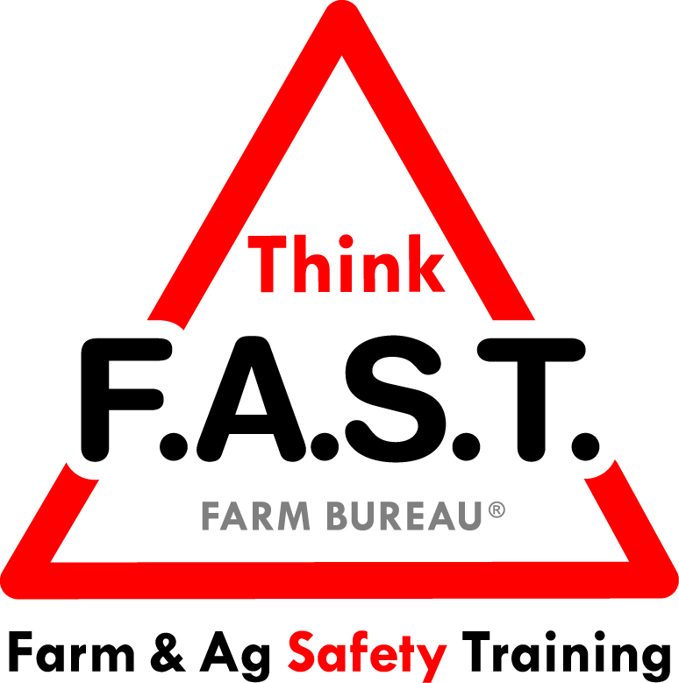

Module 8: Empowerment with Chemicals & Pesticides

Objectives:
- The learner will understand that even as youth, they can be empowered to speak up for safety.
- The learner will demonstrate an understanding and awareness of chemicals and pesticides and know where to search for state-specific regulations.

Time Required:
- Approximately 40 minutes

Materials & Set-Up:
- Pen/paper – per individual
- Examples of chemicals (*empty and clean containers strongly suggested)
- Examples of pesticides (*empty and clean containers strongly suggested)
- Example of chemical labels
- A SDS (formerly MSDS) binder

Lesson:

Introduction
- To engage youth, ask them to think about a time when they felt empowered to do the right thing.
- Ask them how they felt when they stood up for what was right.
- Remind them that for this training, empowerment simply means that they have the ability and authority to take a stand in a positive and respectful way for their safety and the safety of others.
- Preview that today’s focus is on chemicals and pesticides. Remind them that this training does NOT certify them to interact with chemicals, but rather builds an awareness and points them to specific resources.

Suggested Skill Building Activities:
*Note: Instructor may modify for time and regionally-appropriate content, as long as safety and core skills are adequately addressed.

- The Empowerment Toolbox
  - Share the four parts of the empowerment toolbox: being respectful, positive, knowledgeable, and proactive.
  - Ask participants to pair up and share with their partner a time when they demonstrated one of these characteristics in the empowerment toolbox.
  - Bring group back together and ask for a few participants to share. Guide discussion and offer feedback as appropriate.

Core skill: We have to understand that our ability to be empowered should also align with being positive, respectful, proactive, and knowledgeable.
Indicators of activity success:
- Through active participation, learners are engaged in thoughtful responses to the empowerment activity.

- Chemicals & Pesticides
  - Have youth gather around the sample chemical and pesticide containers.
  - With their help, sort the containers into “Chemicals” vs. “Pesticides”
  - Discuss the similarities and differences. Address general use and restricted use.
  - Use the time to address any questions or misconceptions regarding chemicals and pesticides.
    - Refer to state-specific rules and regulations. (See Additional Resources below)

Core skill: We have to understand how to recognize chemicals and pesticides and how to interact with them appropriately.
Indicators of activity success:
- Through active participation, learners demonstrate knowledge or desire to learn about proper handling of chemicals (as appropriate).

- Proper Interactions and Resources
  - Review a sample chemical label with the participants. Describe the use of a label and what it demonstrates about the chemical.
  - Show a SDS (or MSDS) binder and describe what it would be used for and how to properly read it.
  - Tell youth there are common proper procedures when working with chemicals or even being around them. Use the questions below to guide discussion and address misconceptions.
    - How can you recognize when chemicals or pesticides have been applied? How do you know when you can return to the area?
    - What kind of training do you need to work with restricted use chemicals?
    - What kind of PPE and clothing should you wear, regardless of the toxicity?
    - When and how should you wash after being around chemicals?
    - Where and how should the number for Poison Control be located around the farm?

Core skill: We need to be able to understand labels and descriptions to help guide our interactions with chemicals.
Indicators of activity success:
- Through active participation, learners demonstrate knowledge or desire to learn more about proper interactions with chemicals labels, descriptions, and procedures.

Reflection Questions
- To close out the lesson, ask youth the following questions, and allow for individual or group discussion:
  - How can you boost your empowerment toolbox?
  - What is one thing you learned from the chemical and pesticide section of this module that will affect you and your work moving forward?

Challenge
- The next time that you see a chemical or pesticide container, carefully read the label and use your phone or other internet-capable device to search for the SDS, formerly known as MSDS, for that chemical. Research its use, restrictions, and specific hazards. Be aware of what chemicals and pesticides are around you!

Additional Resources:
- Alabama: http://www.agi.alabama.gov/divisions/pesticide-management
- Alaska: https://dec.alaska.gov/eh/pest/
- Arizona: https://agriculture.az.gov/about-us/policies-statutes
- Arkansas: https://www.agriculture.arkansas.gov/pesticide
- California: http://www.cdpr.ca.gov/
- Colorado: https://www.colorado.gov/pacific/agplants/pesticides
- Connecticut: https://portal.ct.gov/DEEP/Pesticides/Pesticide-Management-Program
- Delaware: http://dda.delaware.gov/pesticides/
- Florida: https://www.fdacs.gov/Business-Services/Pesticide-Licensing/Pesticide-FAQ
- Georgia: http://agr.georgia.gov/pesticides.aspx
- Hawaii: http://hdoa.hawaii.gov/pi/pest/
- Idaho: https://agri.idaho.gov/main/56-2/pesticides/
- Illinois: https://www.agr.state.il.us/pesticides
- Indiana: http://oisc.purdue.edu/pesticide/
- Iowa: http://www.iowaagriculture.gov/pesticides.asp
- Kansas: http://agriculture.ks.gov/divisions-programs/pesticide-fertilizer
- Kentucky: http://www.kyagr.com/consumer/agricultural-branch.html
- Louisiana: http://www.ldaf.state.la.us/ldaf-programs/pesticide-environmental-programs/
- Maine: http://www.maine.gov/dacf/php/pesticides/laws.shtml
- Maryland: http://mda.maryland.gov/plants-pests/pages/pesticide_regulation.aspx
- Massachusetts: http://www.mass.gov/eea/agencies/agr/pesticides/pesticide-regulation-in-massachusetts.html
- Michigan: http://www.michigan.gov/mdard/0,4610,7-125-1569_16988---,00.html
- Minnesota: https://www.mda.state.mn.us/pesticide-fertilizer/pesticide-overview
- Mississippi: https://www.mdac.ms.gov/bureaus-departments/plant-industry/pesticide-program/
- Missouri: http://agriculture.mo.gov/plants/pesticides/
- Montana: http://agr.mt.gov/agr/Programs/Pesticides/
- Nebraska: http://www.nda.nebraska.gov/pesticide/
- Nevada: http://agri.nv.gov/Pest-Control/
- New Hampshire: http://agriculture.nh.gov/divisions/pesticide-control/licensing.htm
- New Jersey: http://www.nj.gov/dep/enforcement/dloswpe.html
- New Mexico: http://www.nmda.nmsu.edu/pesticides/
- New York: http://www.dec.ny.gov/chemical/298.html
- North Carolina: http://www.ncagr.gov/SPCAP/pesticides/index.htm
- North Dakota: https://www.nd.gov/ndda/pesticide-fertilizer-division/pesticide-program
- Ohio: https://agri.ohio.gov/wps/portal/gov/oda/divisions/plant-health/pesticides/pesticide-regulation
- Oklahoma: https://www.ag.ok.gov/cps/pesticide.htm
- Oregon: https://www.oregon.gov/ODA/programs/Pesticides/Pages/default.aspx
- Pennsylvania: https://extension.psu.edu/pesticide-laws-and-regulations
- Rhode Island: http://www.dem.ri.gov/programs/agriculture/pesticides-regulatory.php
- South Carolina: http://www.clemson.edu/public/regulatory/pesticide_regulation/
- South Dakota: https://sdda.sd.gov/ag-services/pesticide-program/
- Tennessee: https://agriculture.tn.gov/default.asp
- Texas: https://texasagriculture.gov/RegulatoryPrograms/Pesticides.aspx
- Utah: https://ag.utah.gov/farmers/plants-industry/pesticides/
- Vermont: https://agriculture.vermont.gov/public-health-agricultural-resource-management-division/pesticide-programs
- Virginia: http://www.vdacs.virginia.gov/pesticide-virginia-pesticide-laws-and-regulations.shtml
- Washington: https://agr.wa.gov/washington-agriculture/laws-and-rules/pesticides
- West Virginia: https://wvplants.wvda.us/Index.aspx
- Wisconsin: https://datcp.wi.gov/Pages/Programs_Services/PesticidesFertilizersCertificationLicensing.aspx
- Wyoming: http://wyagric.state.wy.us/divisions/ts/sections-a-programs/pesticide

